BLACKEYED PEA or BLACK-EYED PEA
Blackeyed peas (Vigna unguiculata) are medium-sized (3/8 inch long), ivory-colored beans with a large black coloration (the “eye”) on the inner curve of the beans, where they are attached to the pod. Related to the mung bean, blackeyed peas originated in Eastern Asia. They were brought to the Americas with the African slave trade, and were a staple of many plantation diets. Blackeyed peas have a sweet, mild flavor and firm texture, and absorb the flavors of a dish very well. Blackeyed peas are perhaps best known as a Southern dish, where they are often served with ham and rice. |  | 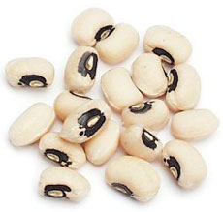
Blackeyed peas are also commonly used in bean cakes, casseroles, curry dishes, fritters and salads. Variations are yellow, brown or red in color. The bean is also known as the black eyed Suzy, brown-eyed pea, cherry bean, China pea, cowpea, frijole, Indian pea, Jerusalem pea, lobhia, marble pea and Tonkin pea.

LENTIL

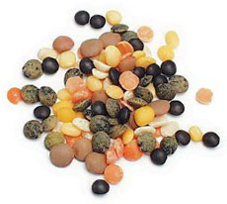
Lens culinaris. Lentils are the seed of a small shrub and is dried after harvesting. Lentils have been eaten for over 8,000 years and originated in southwestern Asia along the Indus River. It is a staple food for many South Asian cultures.Tiny, flat and round, lentils are the fastest cooking of all dried beans that yield a rich, earthy flavor when cooked. The three major varieties are Le Puy, the most intensely-flavored lentil, a tiny green-blue lentil grown without fertilizers in the area around Le Puy en Velay, France, which have a delicate flavor and hold their shape very well; the common green or brown lentil; and yellow and red lentils, which are a staple in Indian cooking, from the spicy Indian dish daal or dal, lentil curry, to the lentil bread daal poori. One can also find ivory lentils, golden lentils and black beluga lentils, so called because they are said to resemble pearls of beluga caviar. Lentils supply a large dose of folate (folic acid), which fights heart disease and prevent birth defects; as well as providing fiber, protein, potassium and magnesium. Lentils are fat-free and absorb spices easily. Versatile, they are used in soups, stews, salads, side dishes.

PINTO BEAN  Phaseolus vulgaris .An oval, beige-colored bean distinguished by its tan splotched surface. It is popular in Mexican dishes including chili, refried beans, rice and beans, soups and stews. |  | 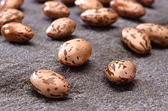
GREEN PEA  Peas (photo at top of page) are a member of the legume family, the seed or seed-pod of the legume Pisum sativum. Each pod contains several peas. It is botanically a fruit because the seeds are contained inside the pod, although like other savory fruits (cucumbers, tomatoes, zucchini) it is treated like a vegetable in food preparation. There are many varieties of peas, including cowpeas, pigeon peas, snow peas and snap peas, which are available fresh, frozen or canned; peas are also grown to produce dry peas like the split pea. |  | 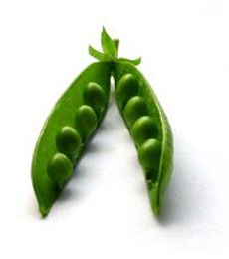

BLACK BEAN
A relative of the kidney bean, the black bean (Phaseolus vulgaris), or common bean, is thought to have originated in southern Mexico and Central America more than 7,000 years ago. Evidence of its use has been found in excavations of prehistoric dwellings. The common bean has since spread around the world. Black beans are small in size with a cream-colored flesh and black skin. They are used throughout Latin America, the Caribbean, and the southern United States (especially Florida and the Southwest). Black bean soups, stews and sauces are very common in Latin American countries and are an important ingredient in Brazilian and Cuban dishes. Black beans are becoming more popular in the U.S., in part due to increased immigration from Latin American countries. They are small, kidney-shaped and shiny, with a slight mushroom flavor. Black beans hold their shape when cooked and absorb flavors well.  CHICKPEA  Cicer arietinum. The chickpea, also known as garbanzo bean, is a legume with a nutty taste and buttery texture often used in Mediterranean dishes. A medium sized plant with feathery leaves, the chickpea grows best in tropical climates and much of the world’s supply is cultivated in India. Chickpeas contain high levels of important nutrients like molybdenum, manganese, folate, and fiber; these nutrients can decrease risk for heart disease and improve overall health. Because chickpeas have a rich flavor, they can be eaten alone with herbs and spices, made into spread (hummus), or used in soups and salads. | 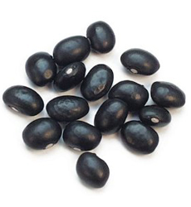

POP CORN
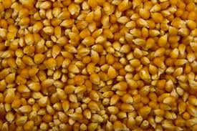
Zea mays everta. Popcorn, also known as popping corn, is a type of corn (maize, Zea mays var. everta) that expands from the kernel and puffs up when heated. Corn is able to pop because, like amaranth grain, sorghum, quinoa and millet, its kernels have a hard moisture-sealed hull and a dense starchy interior. This allows pressure to build inside the kernel until an explosive "pop" results. Some strains of corn are now cultivated specifically as popping corns.

