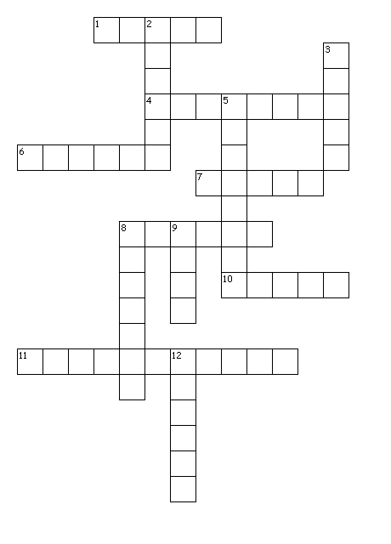**PLANT CLASSIFICATION**

Across

1. Transport tube that carries water from the root to the leaves.

4. Plants that have transport tubes that carry water and nutrients.

6. Organisms that produce their own food.

7. Type of plants that produce two seed-leaves.

8. Plants without a vascular system.

10. Is produced during the photosynthesis.

11. Plants that produce flowers.

Down

2. Parts of the plants where photosynthesis takes place.

3. Vascular plant that produce spores instead of seeds.

5. Type of plants that produce seeds in cones.

8. An example of this plant is the corn.

9. Structure that produce a new plant.

12. Tube that carries sugar away from the leaves.



**Word Search**

|  |  |  |
| --- | --- | --- |
| ANGYOSPERMS | CONES | DICOT |
| FERNS | FLOWERS | GYMNOSPERMS |
| MONOCOT | MOSSES | NON |
| PHLOEM | PLANT | SEEDS |
| SPORES | VASCULAR | XYLEM |

|  |  |  |  |  |  |  |  |  |  |  |  |  |  |  |
| --- | --- | --- | --- | --- | --- | --- | --- | --- | --- | --- | --- | --- | --- | --- |
| F | K | I | V | A | S | C | U | L | A | R | L | H | I | Q |
| W | L | H | O | O | O | B | V | Y | S | S | M | W | E | X |
| U | N | O | T | T | C | L | V | I | M | Y | O | D | G | P |
| U | A | N | W | I | D | M | S | R | R | T | N | Z | V | G |
| L | H | K | I | E | G | N | E | E | E | N | O | G | S | N |
| G | R | R | L | L | R | P | K | Y | P | A | C | L | E | H |
| C | S | I | E | E | S | S | S | K | S | L | O | Z | A | W |
| X | X | U | F | O | I | G | D | F | O | P | T | S | Y | C |
| O | O | Y | Y | D | I | C | O | T | N | O | N | Y | M | O |
| X | D | G | L | P | M | V | O | N | M | Y | X | O | N | N |
| O | N | L | U | E | T | E | E | Y | Y | K | S | W | S | E |
| A | I | E | T | T | M | F | O | B | G | S | O | E | H | S |
| Y | S | E | R | O | P | S | U | L | E | P | E | B | S | R |
| F | U | D | R | R | G | Q | A | S | H | D | L | U | L | F |
| Z | B | M | C | X | T | A | U | W | S | P | A | H | H | A |