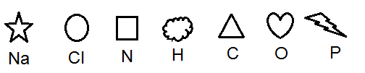
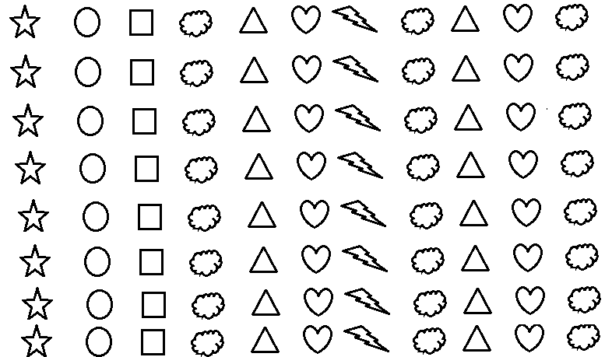

ELEMENTS, COMPOUNDS AND MIXTURES
In your notebooks, use the symbols (color) to represent the formulas below. Classify them as mixtures, compounds or elements.
1. NaCl and H₂O 2. CO₂ 9. Cl
3. H₂O 4. C₆H₁₂O₆ 10. Na Cl
5. PO₃ 6. HCl
7. NH₃ 8. O₂
Invent 1 mixture and 1 compound using the symbols that are left.

