BLACKEYED PEAS  (Vigna unguiculata) are medium-sized (3/8 inch long), ivory-colored beans with a large black coloration (the “eye”) on the inner curve of the beans, where they are attached to the pod. Related to the mung bean, blackeyed peas originated in Eastern Asia. They were brought to the Americas with the African slave trade, and were a staple of many plantation diets. Blackeyed peas have a sweet, mild flavor and firm texture, and absorb the flavors of a dish very well. Blackeyed peas are perhaps best known as a Southern dish, where they are often served with ham and rice. | 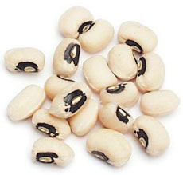
LENTILS  Lens culinaris. Lentils are the seed of a small shrub and is dried after harvesting. Lentils have been eaten for over 8,000 years and originated in southwestern Asia along the Indus River. It is a staple food for many South Asian cultures.Tiny, flat and round, lentils are the fastest cooking of all dried beans that yield a rich, earthy flavor when cooked.. Lentils supply a large dose of folate (folic acid), which fights heart disease and prevent birth defects; as well as providing fiber, protein, potassium and magnesium. Lentils are fat-free and absorb spices easily. Versatile, they are used in soups, stews, salads, side dishes. | 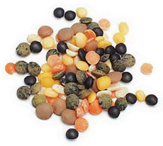
PINTO BEANS
Phaseolus vulgaris .An oval, beige-colored bean distinguished by its tan splotched surface. It is popular in Mexican dishes including chili, refried beans, rice and beans, soups and stews.
GREEN PEA  Peas (photo at top of page) are a member of the legume family, the seed or seed-pod of the legume Pisum sativum. Each pod contains several peas. It is botanically a fruit because the seeds are contained inside the pod, although like other savory fruits (cucumbers, tomatoes, zucchini) it is treated like a vegetable in food preparation. There are many varieties of peas, including cowpeas, pigeon peas, snow peas and snap peas, which are available fresh, frozen or canned; peas are also grown to produce dry peas like the split pea. | 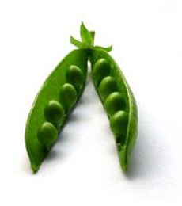
CHICKPEA
Cicer arietinum. The chickpea, also known as garbanzo bean, is a legume with a nutty taste and buttery texture often used in Mediterranean dishes. A medium sized plant with feathery leaves, the chickpea grows best in tropical climates and much of the world’s supply is cultivated in India. Chickpeas contain high levels of important nutrients like molybdenum, manganese, folate, and fiber; these nutrients can decrease risk for heart disease and improve overall health. Because chickpeas have a rich flavor, they can be eaten alone with herbs and spices, made into spread (hummus), or used in soups and salads.
POPCORN  Zea mays everta. Popcorn, also known as popping corn, is a type of corn (maize, Zea mays var. everta) that expands from the kernel and puffs up when heated. Corn is able to pop because, like amaranth grain, sorghum, quinoa and millet, its kernels have a hard moisture-sealed hull and a dense starchy interior. This allows pressure to build inside the kernel until an explosive "pop" results. Some strains of corn are now cultivated specifically as popping corns. | 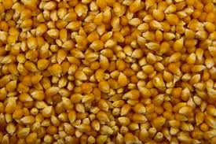
SMALL RED BEANS
(Phaseolus vulgaris) are a plump, round bean with a deep brick red color. This bean is about 1/2" long with a mild flavor and firm texture and holds its shape well. Small Red Beans are also known as Habichuelas and Habas Pequenos Colorados. This is a bush bean rather than a vine bean. This is the bean which is famous in the Southern dish

